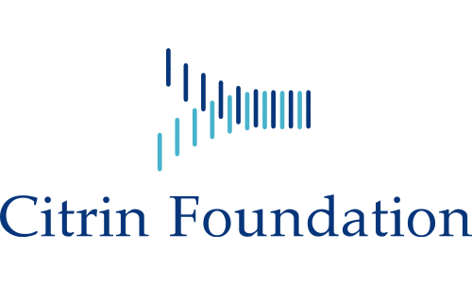

Form A
Title of Scientific Proposal
Duration of the Proposal
Reminder to applicants:
- The proposal should be presented single spaced and in Times New Roman 12-point lettering with a maximum of 6 pages, excluding references.
- References are limited to a maximum of 30 literature references.
- All applications should be accompanied by separate PDFs for the Proposer and each member of the research team containing their CVs including their list of scientific publications.
- All word limits should be followed strictly and within the provided space. Non-conforming proposals will be returned to the applicant without review.
- A detailed introduction of citrin deficiency is not required unless needed to support the study aims.

Section 1 – Summary of the proposal (250 words maximum)
Section 2 – Brief introduction (400 words maximum)

Section 3 – Relevance of the application to the Foundation’s Mission (400 words maximum)

Section 4 – The proposal: including objectives, design, methods to be employed, names and roles of members of the research team, and a graphical summary of milestones. (Maximum 6 pages)
Section 5 – The budget with justifications (in USD)

Section 6 – Brief description of facilities to be used in carrying out the proposal
Section 7 – Responsibilities and roles of each named member of the research team

